AI-Based Waste Management System
STATISTICAL MACHINE LEARNING (CSET -211)

Submitted by-
Dhruv Rajvanshi (E23CSEU0155)
Ayush Kumar Pathak (E23CSEU0173)
Parth Yaduvanshi (E23CSEU0154)
Submitted to- Dr. Sanchali Das


Abstract
This project leverages Artificial Intelligence to classify waste into biodegradable and non-biodegradable categories using Convolutional Neural Networks (CNNs). The model achieved an accuracy of 93.83%, demonstrating its potential to improve waste management efficiency and support eco-friendly practices.

Introduction
The rapid generation of waste globally poses a significant challenge to environmental sustainability. Traditional waste segregation is labor-intensive and prone to inefficiencies. This project employs Convolutional Neural Networks (CNNs) to automate waste classification, addressing these challenges and supporting effective recycling and disposal.

Aim and Objectives
Aim-
To develop an AI-based system capable of classifying waste into biodegradable and non-biodegradable categories. This classification enhances waste management efficiency and lays the groundwork for sustainable practices.
Objectives-
- Efficiently classify waste types into biodegradable and non-biodegradable categories.
- Optimize the classification model for real-world applications.
- Lay the foundation for advanced classifications like waste-to-energy and waste-for-construction initiatives.

Methodology
- Dataset Preparation: Images resized to 224x224, normalized, and augmented to improve model generalization.
- Model Design: CNN trained using TensorFlow and Keras, comprising convolutional, pooling, dense, and dropout layers.
- Training and Evaluation: Early stopping and learning rate scheduler were employed to optimize performance.
- Testing: Model achieved a test accuracy of 93.83%.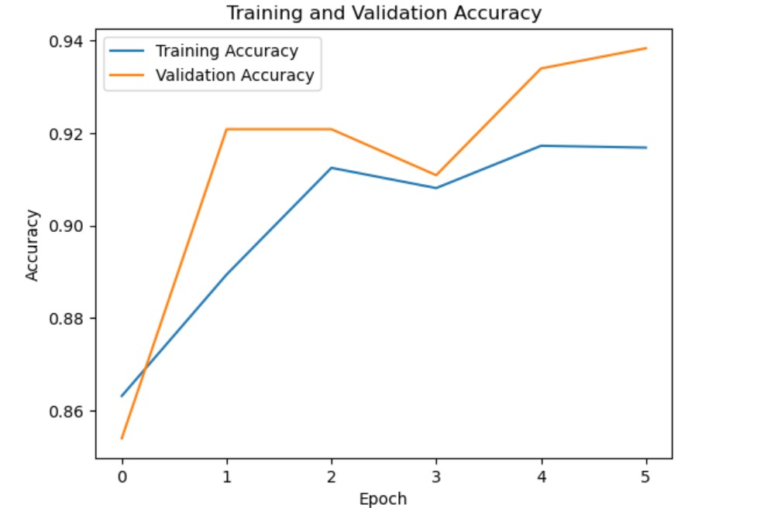

Experimental Results
- Training Accuracy: 94.50%
- Validation Accuracy: 93.83%
- Test Accuracy: 93.83%
These results demonstrate the model's reliability for waste classification and its potential for practical deployment.

Future Scope
- Expand dataset to include more waste categories.
- Develop multi-class classification capabilities for complex waste categorization.
- Optimize the model for real-time edge deployments.
- Integrate the system with IoT-based automated segregation systems.
- Implement waste-to-energy and road construction material utilization for non-biodegradable waste.

Conclusion
The project successfully developed a CNN-based system for waste classification, achieving an accuracy of 93.83%. This model serves as a step towards smarter waste management and sustainability. Future work will focus on enhancing its capabilities for broader applications, including waste-to-energy conversion and integration into IoT systems.

GitHub Link
https://github.com/Rajvanshi-Dhruv/Waste-Management-System/tree/main

